Title of the Paper - Clear, Descriptive, not Too Long and Written without Any Abbreviations (16pt Times New Roman, Bold, Left, Title Case)

Given Name Family Name (in full)^{1*}, Given Name Family Name (in full)² (12pt Times New Roman, bold, left)

¹Department (10pt Times New Roman, italic, left)
University (10pt Times New Roman, italic, left)
Address (10pt Times New Roman, italic, left)
E-mail: author_email@xxx.xxx (10pt Times New Roman, italic, left)

²Department (10pt Times New Roman, italic, left)
University (10pt Times New Roman, italic, left)
Address (10pt Times New Roman, italic, left)
E-mail: author_email@xxx.xxx (10pt Times New Roman, italic, left)

*Corresponding author

Received: filled by editor | Accepted: filled by editor
 | Published: filled by editor

Abstract: An abstract of no more than 200 words should state the purposes of the study, procedures, findings and conclusions. (10pt Times New Roman, italic, justified)

Keywords: Please leave an empty paragraph after the Abstract and write your keywords (3 - 6 words) – Keyword one, Keyword two, Keyword three. (10pt Times New Roman, italic, justified)

All paragraphs up to here should be formed as a head of paper with format paragraph Left and Right: 1.4 cm.

Introduction
This is a sample of the format of your paper.

Manuscripts should be written in English. Authors whose native language is not English are strongly advised to have their manuscripts proofread by an English-speaking colleague prior to submission.

Types of contributions
1. Original research papers (no more than 16 pages) should report the results of original research. The material should have not been previously published elsewhere, except in a preliminary form.

2. Review articles (no more than 24 pages) should cover subjects falling within the scope of the journal, which are of active current interest. They may be submitted or invited.

3. An application note should be a short but complete description of a specific application, which will not be included in a later paper. It should not occupy more than 6 printed pages, including figures, tables and references.

Page setup – A4-sized pages (21×29.7 cm) pages with top, bottom, left and right margins of 2.5 cm. Header and Footer – 1.25 cm. Main body text should be 12pt size Times New Roman, Line Spacing Single, Justify. Please, leave empty line between separate paragraphs.

The heading of each section should be typed in Sentence case, Times New Roman 14pt, Left, Bold. Do not use sections’ numbering.

If some abbreviations are used in the text, they should be defined in the text where they appear for the first time.

Materials and methods
Subsection(s)
When including a subsection, its heading should be typed in Sentence case, Times New Roman 14pt, Left, Italic (as an example: Subsection). The text should follow the heading immediately, without an empty paragraph.

Sub-subsection(s)
When including a sub-subsection, its heading should be typed in Sentence case, Times New Roman 12pt, Left, Italic (as an example: Sub-subsection). The text should follow the heading immediately, without an empty paragraph.

Results and discussion
The results and discussion may be combined into a common section or presented separately. They may also be broken into subsections with short, informative headings.

Formulae
All symbols should be italic. Subscripts and superscripts should be clear and not too small. Give the meaning of all symbols immediately after the equation in which they are used for the first time. Greek and other non-Latin letters and symbols should be explained in the first place where they appear. Take special care to show clearly the difference between digit zero (0) and the letter O, and between digit one (1) and the letter l. Equations should be numbered consecutively with Arabic numbers. The number should be in parentheses at the rightmost according to the page margin. In general, only equations explicitly referred into the text need to be numbered. Citations in the text should be with parentheses. SI units should be used.

(1)
(2)

Tables and figures
Tables should be numbered (with Arabic numbers) consecutively following the order of their first citation in the text.

Table 1. Statistical data of the absorbance measurements obtained by the biosensor
ACh concentration | n | Mean | Standard deviation | Coefficient of variation | R.S.D. % | Variance
2.5 mM | 10 | 0.0577 | 0.00207 | 0.03788 | 3.78 | 0.000004
30 mM | 10 | 0.2462 | 0.01077 | 0.046106 | 4.61 | 0.000116

Figures should be prepared professionally and with high contrast. All illustrations should be numbered consecutively. The amount of lettering on a drawing should be reduced as far as possible by transferring information to the legend. Figures with their captions are included in the text at the correct place and receive Arabic numbers, which should appear in the text. Tables and figures should be referred to in the text as follows: “Table 1”, “Fig. 1”, using regular typeface.

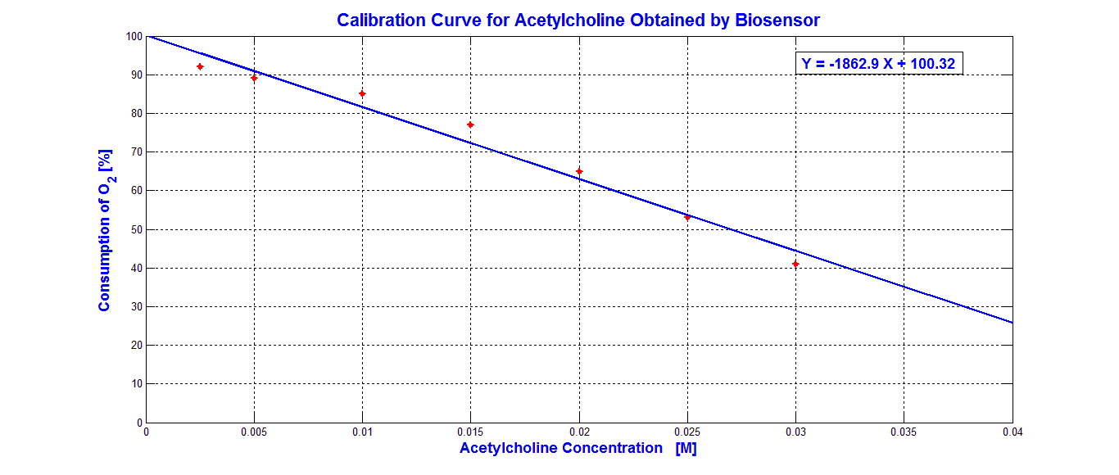
Fig. 1 The calibration curve of acetylcholine

Conclusion
This section should clearly state the main conclusions of the research and give a comprehensible explanation of their importance and relevance.

Acknowledgements
This section should be typed in character size 12pt Times New Roman, Italic, Justified.

References
All publications cited in the text should be presented in a list of references following the text of the manuscript. The references should be listed in alphabetical order with Arabic numbers and with hanging of 0.7 cm.

Citations in the paper should be with square brackets [1, 5, 10-13].

In the case of references published in any language other than English, the whole bibliographic record has to be translated in English and a notation such as “(in Russian)” or “(in Greek with English abstract)” should be added.

Work accepted for publication but not yet published should be referred to as “(in press)”.

Reference examples:
- Edger R. C. (2009). Optimizing Substitution Matrix Choice and Gap Parameters for Sequence Alignment, BMC Bioinformatics, 10, 396-405.
- Hompson J., D. Higgins, T. Gibson (1994). CLUSTAL W: Improving the Sensitivity of Progressive Multiple Sequence Alignment through Sequence Weighting Position Specific Gap Penalties and Weight Matrix Choice, Nucleic Acids Research, 22(22), 4673-4690.
- Rosenblat D. (1960). On Some Aspects of Models of Complex Behavioural Systems in Information and Decision Processes (Eds., R. E. Machol, McGraw Hill), New York.
- Murray J. D. (1995). Mathematical Biology, Springer, Verlag.
- http://www.mathworks.com/ (access date 20 March 2012)

Given Name Family Name (in full)
E-mail: author_email@xxx.xxx

Place here a photograph of the author (no larger  than 3x4 cm) | Please provide a short CV of the author (up to 100 words).

Given Name Family Name (in full)
E-mail: author_email@xxx.xxx

Place here a photograph of the author (no larger  than 3x4 cm) | Please provide a short CV of the author (up to 100 words).

 | © 2024 by the authors. Licensee Institute of Biophysics and Biomedical Engineering, Bulgarian Academy of Sciences. This article is an open access article distributed under the terms and conditions of the Creative Commons Attribution (CC BY) license (http://creativecommons.org/licenses/by/4.0/).

